* 

BUSINESS PLAN - “FLARBLE”

**Objective:**  
Create a rudimentary business plan to assess the challenge of building an online tutoring service.

* **Executive Summary**
  + Company Name:
    - Flarble
      * From an online alias I used
  + **BUSINESS OVERVIEW**
    - **To offer tutoring sessions and freelance web development at a low price to the public via online communication using discord or skype.**

NOTES:

* + Problem
    - Due to increasing popularity of the web development career path and the pandemic there are many people looking to learn a new skill.
  + Solution
    - Offer a straightforward, beginner friendly one-on-one service to learn the skills required to build static websites.
  + Target Market
    - 18-35 years of age, male.
  + **Competition**
    - **Needs further attention**
    - **Lots of competition, but what I may not make charging low rates I can make up for in knowledge and experience.**

NOTES:

* + **THE TEAM**
    - **Just me for now, could bring more in through discord connections made over time.**
  + **Financial Summary**
    - **NEED TO DEVELOP**
      * **Pricing strategy**
      * **Invoicing**
      * **Where to find customers? (Advertising?)**

NOTES:



Market analysis and market research

If you are going to do a [market analysis](https://articles.bplans.com/how-to-write-a-market-analysis/), start with some research. First, identify your market segments and determine how big each segment is. A market segment is a group of people (or other businesses) that you could potentially sell to.

* **THE WEBSITE:**
* **Loading screen ( what you see when page is first opened)**
* 
* HERO SECTION: What you see when the page is done loading
* 

NOTES:

* “ABOUT” Section – Services offered, etc.
* 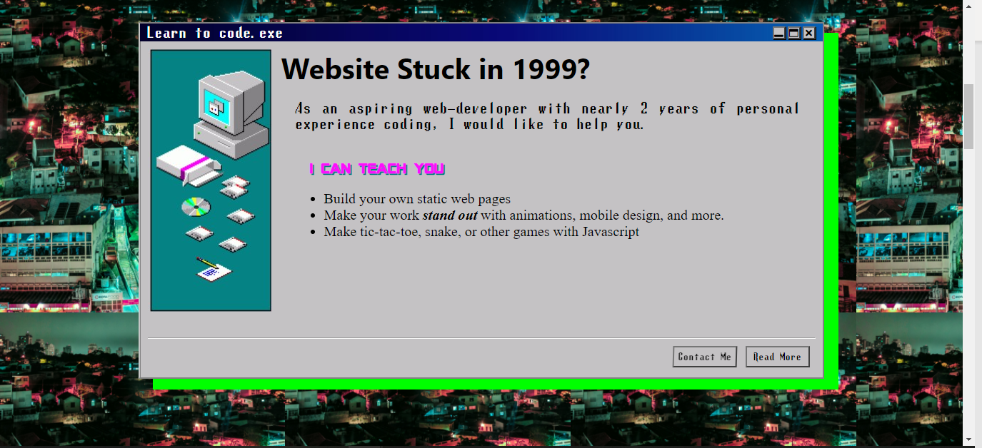
* My portfolio inside of a windows 98 themed window
* 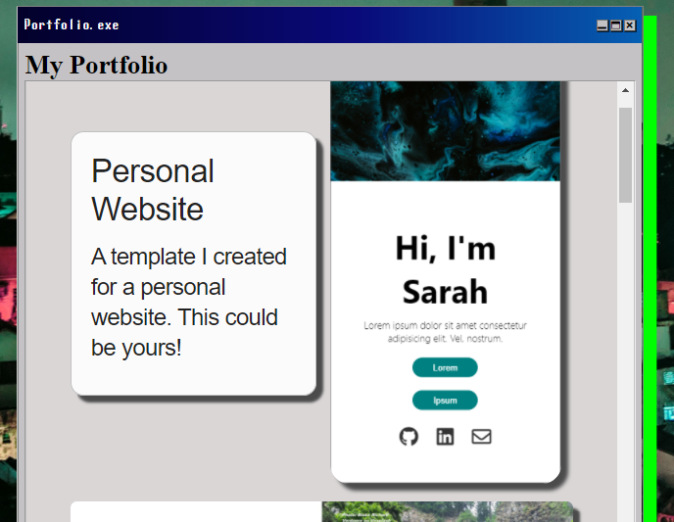

NOTES:

* 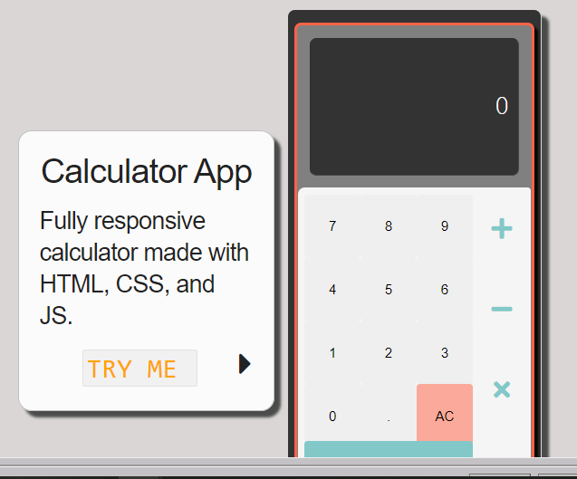
* 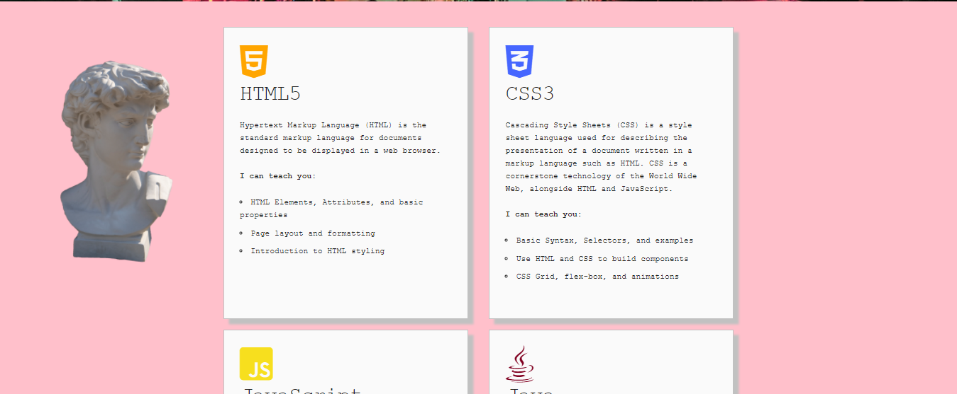

NOTES:

* 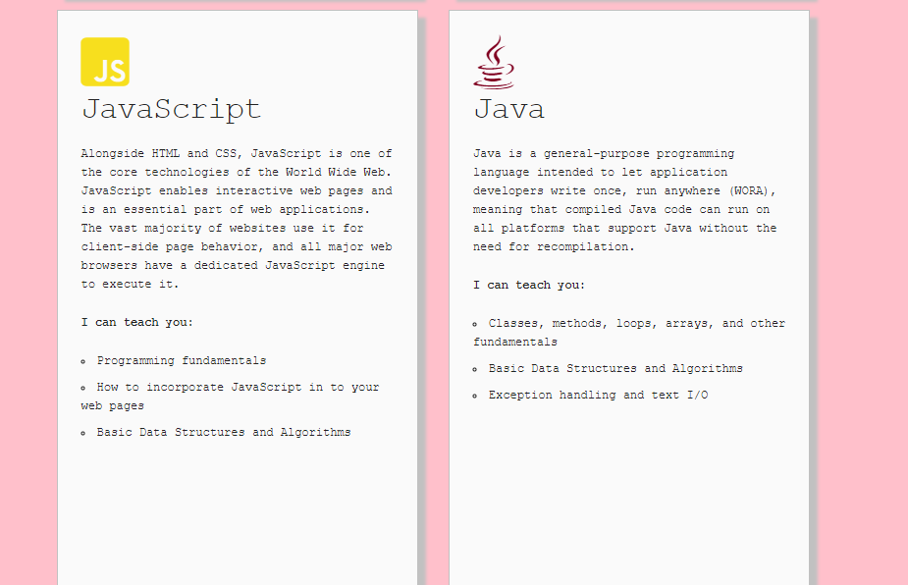

NOTES:

* CONTACT CARD (click to copy)
* 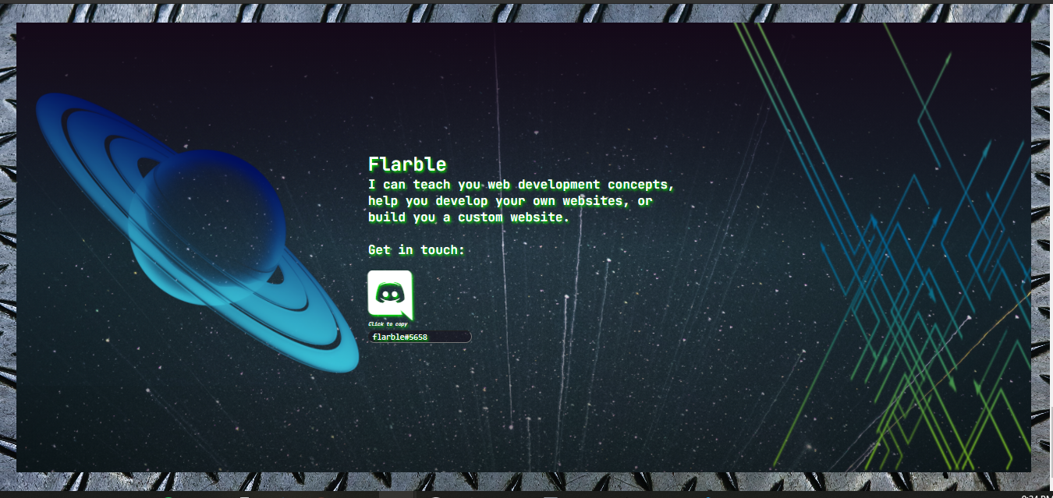

NOTES: